Western Union Settlement JOB AID
Description | Balancing Western Union Demand Accounts: 101007999284; 101008000167
Target audience | Centralized Services - Reconciliations
Prerequisites | T24, GlobalPay (WUBS), busienssonlinewires group email access
Date published

Policy statements
- Centralized Services Manual- Centralized Services is responsible for balancing Western Union’s Demand accounts to the Western Union Settlement and CWB’s clients.

Steps
Step | Instruction
1 | Open Western Union Reconciliation  CAD: \\cwb.local\shared\Corp\CAP\Reconciliations\Western Union\WU_Settlement_CAD.xlsx  USD: \\cwb.local\shared\Corp\CAP\Reconciliations\Western Union\WU_Settlement_USD.xlsx
2 | Pull the Closing Balances at 1:00 PM MST of the Western Union Demand Accounts 101007999284 & 101008000167 for settlement date from T24  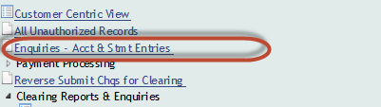  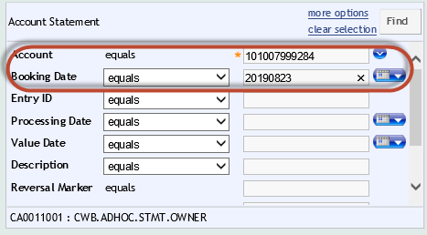
3 | Enter Closing Balances into the settlement  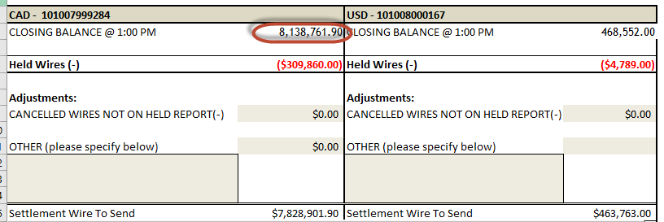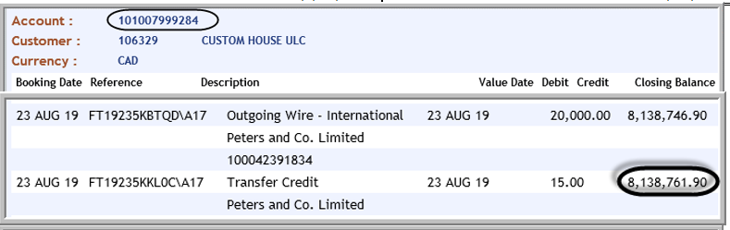
4 | Open the Held Wires report that is sent to businessonlinewires@cwbank.com  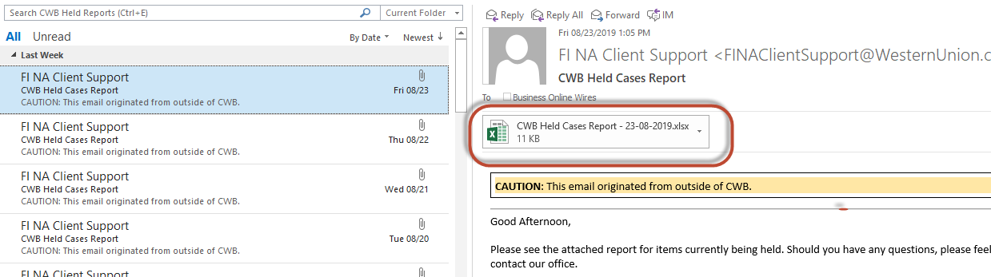
5 | Copy and paste the details into the settlement tab “Held Payments”  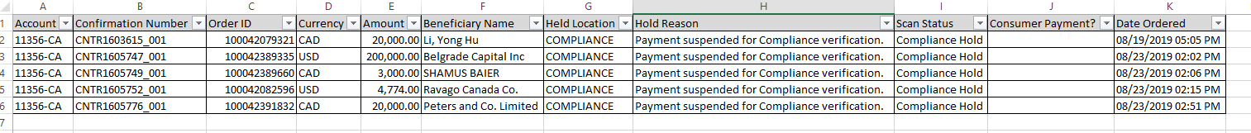  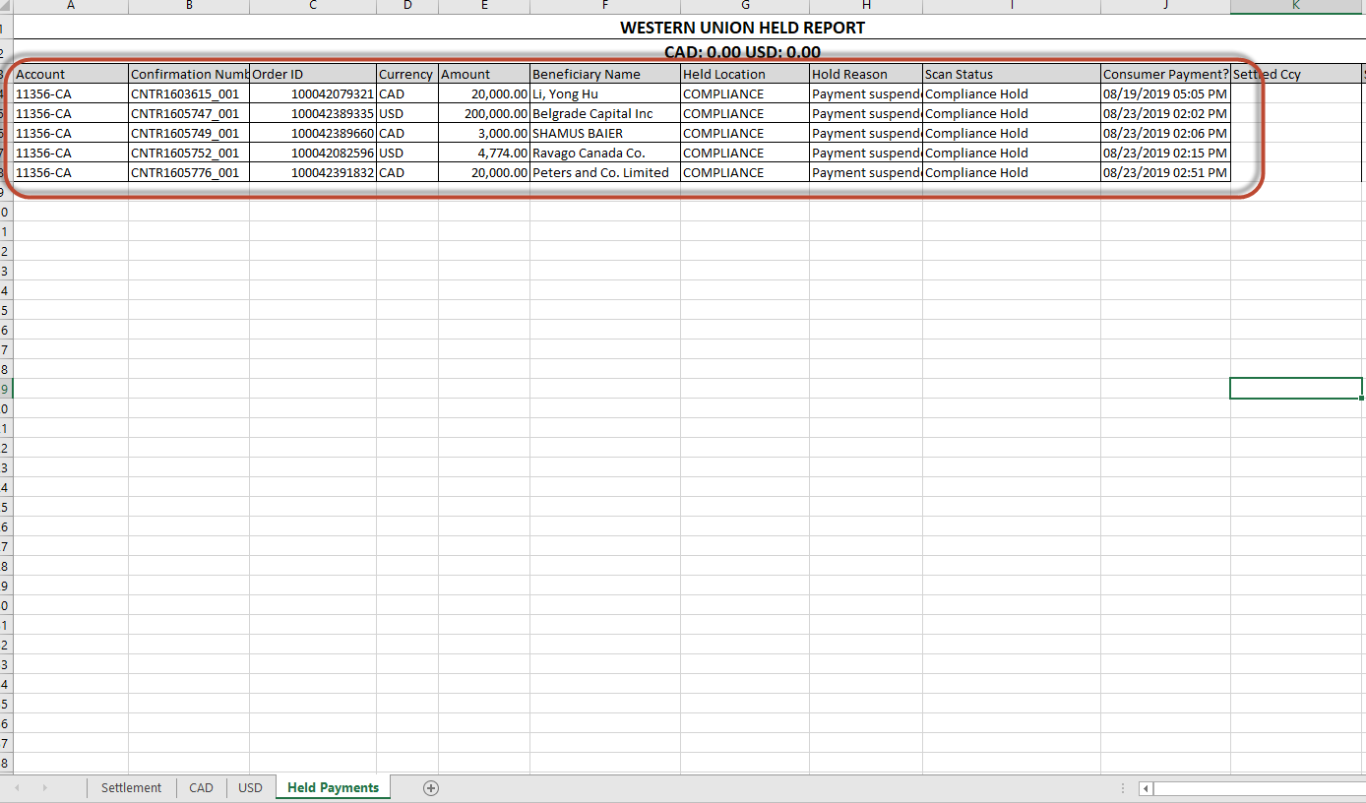
6 | Pull Managed Pricing Report from WUBS.
7 | Look up the Order number and find the settled currency and settled amount.  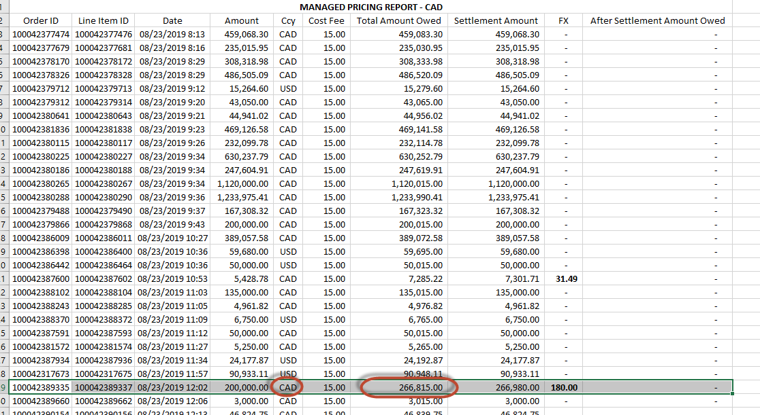  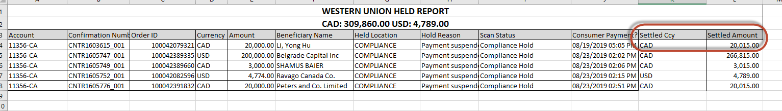
8 | Print all the worksheets in the settlement. Sign the CAD and USD posting sheets and bring to two authorized signers.  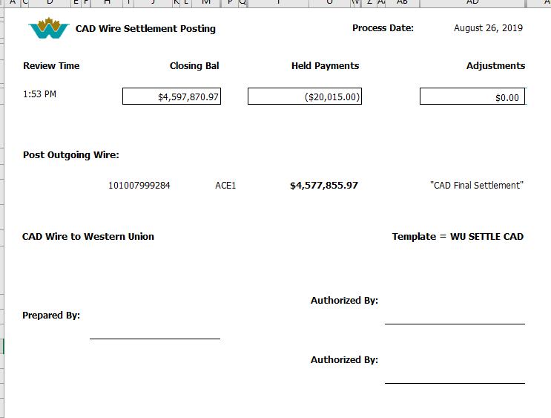
9 | Once the authorizers have signed off, make a copy of the postings, one for the poster and one for the wire inputter.
10 | Enter the details of the outgoing wires in the outgoing wire tracking sheet: N:\Centralized Services\Outgoing Wires\Outgoing Wires Master Tracking.xlsx and ACME solutions (future state)
11 | Email Western Union advising of the settlement for the day:  To: FINAClientSupport@WesternUnion.com ; AccountsReceivableNA@WesternUnion.com  Cc: Patrick Cunningham <Patrick.Cunningham@WesternUnion.com>; Rana Abdo <Rana.Abdo@WesternUnion.com>; Leeanna Tieu <Leeanna.Tieu@WesternUnion.com>; Roosevelt Lewis <Roosevelt.Lewis@WesternUnion.com>; Mari Hornback <Mari.Hornback@WesternUnion.com>; TGBPCashManagement <TGBPCashManagement@WesternUnion.com>; CAP Managers <CAPManagers@cwbank.com>; Business Online Wires BusinessOnlineWires@cwbank.com  Subject: Settlement for Date  Good afternoon,  Today CWB sent a wire for $7,828,901.90 CAD ( Closing Balance $8,138,761.90 CAD - Held Payments $309,860.00 CAD)  and a wire for $463,763.00 USD ( Closing Balance $468,552.00 USD - Held Payments $4,789.00 USD)  Thank you
12 | Email CWB’s treasury cash management team of outgoing wire amounts  To: Treasury Cash Management TreasuryCashManagement@cwbank.com  Subject: WU FINAL OUT $$$ CAD & $$$ USD

